**COMMUNITY BOARDS**

601 Van Ness Avenue, Suite 4020 - San Francisco, CA 94102

(415) 920-3820 | Fax: (415) 920-3821 | www.communityboards.org

The Basics of Mediation Scholarship Application

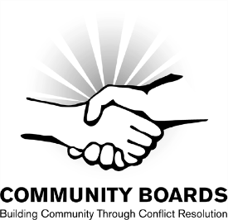  
Community Boards primarily awards scholarships to individuals residing and nonprofit organizations based in San Francisco. The primary goal of our scholarship program is to maintain and expand the diversity of our pool of Community Mediators. We evaluate applications based on our current demographic and program needs.

All information remains confidential. Recipients may be requested to provide additional program, outreach and/or public education assistance. **All scholarships are awarded at the sole discretion of Community Boards.**

**DEADLINE**: **Completed applications must be submitted no later than four weeks prior to the selected training date.** Email or fax your completed application to Karen Lipney, ADR Programs Director, klipney@communityboards.org. If you have questions, email or call Karen at (415) 920-3829 x109.

**Today’s Date**: --

* **Name**: --
* **Street & Unit #**: -- **City**: -- **Zip**: --
* **Telephone**: -- **Email**: --
* **Age**: --
* **Race or ethnicity**: --
* **Occupation**: --

**Basics Training Date:** --

**Scholarship Level**

Full: $795  Half: $397.50 (Recipient pays $397.50)  Partial: $200 (Recipient pays $595)

**Languages you’re fluent in:**  English  Spanish  Cantonese  Mandarin  Other --

**Your sexual orientation:**  Straight  Gay/Lesbian  Bisexual  Other: --

**Your gender:**  Female  Male Transgender  Other: --

**Are you a renter or homeowner?**

Renter  Homeowner

**Below, briefly discuss your financial need and why you want to be a Community Mediator.**

|  |
| --- |
|  |